

**Name: Syed Muhammad Fahad Fiaz**

**Roll No: BSSEM-S24-036**

**Section: SE 3A**

**Subject: Data Structure and Algorithms**

**Submitted To: Sir Rasikh Ali**

**Submission Date:**

**Assignment 10**

**DSA LAB TASK’S**

**LAB 10:** Stack with Linkedlist and Array

Tasks:

1. With Array; Push, Pop, Display

2. With Linkedlist; Push, Pop, Display

**Explanation:**

**Stack using Array (Theory)**

* **Push**:  
  Add new data at the next empty index in the array.  
  Increase top by 1.
* **Pop**:  
  Remove the last inserted element.  
  Decrease top by 1.
* **Display**:  
  Start from top and print elements down to index 0.

Important:  
In array stack, the size is **fixed** (limited).

**Stack using Linked List (Theory)**

* **Push**:  
  Create a new node.  
  Set the new node's next to the current top.  
  Update top to the new node.
* **Pop**:  
  Delete the current top node.  
  Move top to the next node.
* **Display**:  
  Start from top and print all nodes one by one.

Important:  
In linked list stack, the size is **dynamic** (no fixed limit).

**OUTPUT FOR ARRAY:**

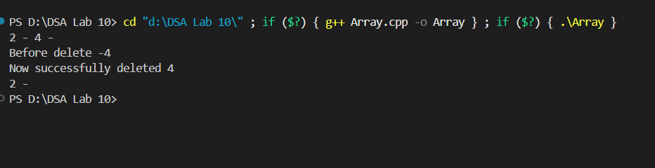

**OUTPUT FOR Linked List:**

